**KARE (Kerala united Against Rare Disease)**

**Introduction**

**KARE (Kerala United Against Rare Diseases)** is a comprehensive care programme initiated by the Government of Kerala to support individuals affected by rare diseases. The programme focuses on prevention, early identification, and provision of treatment wherever available, along with access to medicines, appropriate therapies, and assistive technological devices, while also emphasizing home-based services and psychosocial support for parents and caregivers to improve the quality of life of persons living with rare diseases.

As part of this initiative, the Government of Kerala became the first state in India to launch a state-funded treatment programme for Spinal Muscular Atrophy (SMA), which was formally initiated in **March 2022**.

**Evolution of the KARE Program**

Drawing from the successful experience of the SMA program (2022–2024), the Government of Kerala launched the KARE initiative (Kerala United Against Rare Diseases) in 2024.

**Vision:**

To create a sustainable model for comprehensive care and treatment access for children with rare diseases in Kerala.

**Mission:**

To mobilize alternative funding (philanthropy, CSR, public donations) and ensure equitable access to high-cost treatments for conditions such as SMA, Gaucher, Pompe, MPS, and others.

**Objectives:**

● Ensure uninterrupted therapy for eligible patients

● Provide holistic care through public health infrastructure

● Build a transparent, accountable funding ecosystem

**The Way Forward**:

Kerala’s model has shown that early diagnosis, multidisciplinary care, and timely drug access can transform outcomes in rare diseases like SMA. However, the program’s sustainability depends on continued funding.

Through KARE, we aim to raise ₹100 crore over the next 3 years to ensure uninterrupted care for existing patients and inclusion of other rare disease categories.

We invite philanthropists, corporates, and organizations to partner with us in this compassionate mission.

In order to facilitate expert medical treatment for these children and to support this noble initiative, donations are solicited from generous and broad-minded individuals across the country.

**Bank Details for Donation:**

* **Name of Bank:** State Bank of India, Trivandrum City (70028)
* **Account Number:** 39229924684
* **IFSC Code:** SBIN0070028

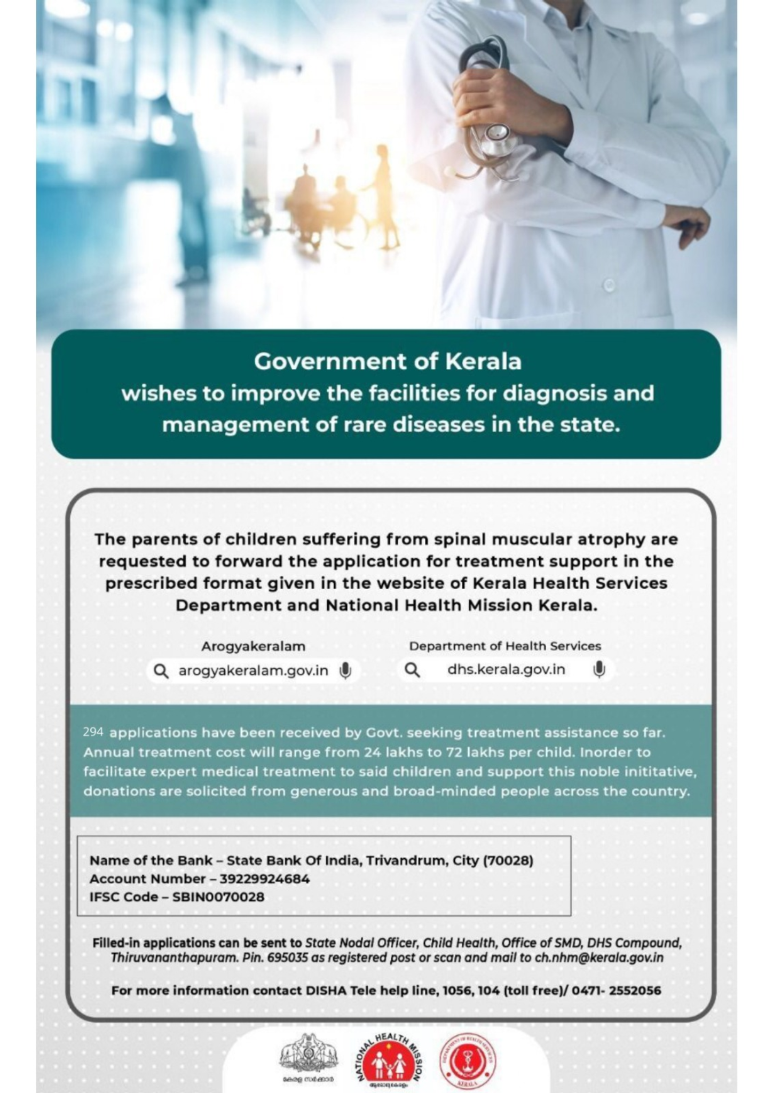

**KARE LOGO**

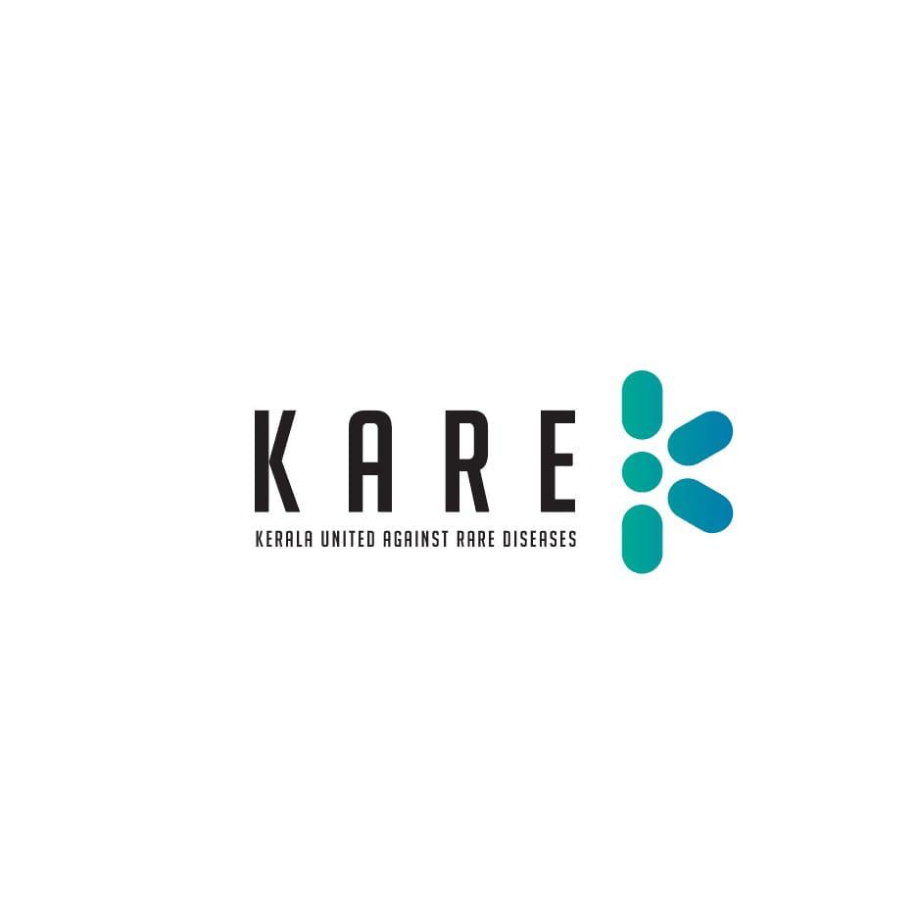

**PICTURES**

